Expense Splitter Pro: A Full-Stack Group Expense Splitting and Budget Analytics Platform
A Project Report Submitted in partial fulfillment of the requirements for the award of the degree of
BACHELOR OF TECHNOLOGY
IN
DEPARTMENT OF COMPUTER SCIENCE AND ENGINEERING
&
DEPARTMENT OF COMPUTER SCIENCE AND INFORMATION TECHNOLOGY
By
Bhavanam Ritvik Reddy | 2520030283
Sinde Vedhanth | 2520030004
Mandala Yeshwanth | 2520030525
Under the Esteemed Guidance of
Dr. Ramya Krishna
Assistant Professor
Department of Computer Science and Engineering
Koneru Lakshmaiah Education Foundation
(Deemed to be University estd. u/s. 3 of the UGC Act, 1956)
Off-Campus: Bachupally-Gandimaisamma Road, Bowrampet, Hyderabad, Telangana - 500 043.
Website: www.klh.edu.in
Academic Year 2024-2025

DECLARATION
The Project Report entitled “Expense Splitter Pro: A Full-Stack Group Expense Splitting and Budget Analytics Platform” is a record of bonafide work carried out by BHAVANAM RITVIK REDDY (2520030283), SINDE VEDHANTH (2520030004), and MANDALA YESHWANTH (2520030525) submitted in partial fulfillment for the award of Bachelor of Technology in Computer Science and Engineering / Computer Science and Information Technology to K L University. The results embodied in this report have not been copied or reproduced from any other department, university, or institute.
BHAVANAM RITVIK REDDY – 2520030283
SINDE VEDHANTH – 2520030004
MANDALA YESHWANTH – 2520030525
Date: 02-10-2026
Place: Hyderabad

CERTIFICATE
This is to certify that the project-based report entitled “Expense Splitter Pro: A Full-Stack Group Expense Splitting and Budget Analytics Platform” is a bonafide work done and submitted by BHAVANAM RITVIK REDDY (2520030283), SINDE VEDHANTH (2520030004), and MANDALA YESHWANTH (2520030525) in partial fulfillment of the requirements for the award of the degree of BACHELOR OF TECHNOLOGY in Department of Computer Science and Engineering / Department of Computer Science and Information Technology, K L (Deemed to be University), during the academic year 2024-2025.
Signature of the Guide Signature of Course Coordinator Signature of HOD
(Dr. Ramya Krishna) (Course Coordinator) (Dr. P. Venkateshwara Rao / Dr. Kaja Shareef)

ACKNOWLEDGEMENT
The success in this project would not have been possible without the timely help and guidance rendered by many people. We wish to express our sincere thanks to all those who have assisted us in one way or the other for the completion of our project.
Our greatest appreciation goes to our Course Coordinator and Guide, Dr. Ramya Krishna, Assistant Professor, Department of Computer Science and Engineering, which cannot be expressed adequately in words for her tremendous support, valuable guidance, and continuous encouragement throughout the development of this project.
We express our gratitude to Dr. P. Venkateshwara Rao (HOD, CSE) and Dr. Kaja Shareef (HOD, CSIT), Department of Computer Science and Engineering / Information Technology, for providing us with adequate laboratory facilities and computing infrastructure by which we were able to complete this Database Systems Engineering (DBSE) project-based work.
We thank all the members of teaching and non-teaching staff, and all those who have assisted us directly or indirectly for the successful completion of this project. Finally, we sincerely thank our parents, friends, and classmates for their kind cooperation and constant moral support during our work.

ABSTRACT
The Expense Splitter Pro platform is a modern, full-stack web-based financial management system engineered to automate, streamline, and optimize shared group expenses and group budget monitoring. In modern collaborative environments such as college dormitories, shared student apartments, capstone project teams, and group vacation outings, individuals frequently incur shared costs ranging from groceries, meals, and utilities to travel tickets and supplies. Tracking these informal obligations manually using physical paper notes, group chat messages, or basic spreadsheets leads to frequent computational mistakes, forgotten debts, lack of budget oversight, and social friction among peers.
To resolve these challenges, this project presents the Design and Implementation of Expense Splitter Pro, a unified, responsive single-page application (SPA) backed by an enterprise-grade RESTful API. Built upon a decoupled multi-tier architecture, the presentation tier is engineered with React 19, Vite, modern CSS systems, Lucide React icons, and Recharts for interactive graphical analytics. The server tier is developed using Node.js and Express 5, integrating connection-pooled MySQL2 drivers that execute strict ACID-compliant transaction blocks (START TRANSACTION, COMMIT, ROLLBACK) for multi-row expense distribution logging.
The relational database layer is designed in MySQL 8.0, normalized into Third Normal Form (3NF) to support users, groups, memberships, expenses, split shares, and settlement records with cascading foreign-key integrity. The platform features three distinct splitting mechanisms (Equal, Exact, and Percentage), an automated greedy cash-flow simplification engine that minimizes bilateral transfers, real-time budget tracking progress meters, category breakdown pie/bar charts, and session-based authentication. The application delivers sub-second response times, complete cross-device mobile responsiveness, and has been thoroughly validated via Postman automated collections.

INDEX / TABLE OF CONTENTS
S. No. | Chapters | Topics | Page No.
- | Acknowledgement | Acknowledgement of mentors and institution | 4
- | Abstract | Executive summary of Expense Splitter Pro | 5
1 | Introduction | Background, Problem Statement, Scope, Objectives, Importance, Target Audience | 7-13
2 | System Requirements | Hardware requirements, Software requirements, Development tools | 14-15
3 | Technology Stack | Frontend, Backend, Database, Version Control, External libraries & APIs | 16-19
4 | System Architecture | High-level architectural diagram, Layer descriptions, Data flow, Deployment view | 20-22
5 | Design | ER Diagram, Relational schema, Database normalization (3NF) | 23-25
6 | Implementation | Module-wise implementation, Frontend UI & state, REST API integration, Debt resolution | 26-30
7 | Features | Core feature list, Functional descriptions (User & Technical perspectives) | 31-34
8 | Testing | Postman API testing, Transactional integration testing, Test cases & results | 35-38
9 | Deployment | Local deployment steps, Environment configuration (.env), Docker containerization | 39-41
10 | Challenges & Limitations | Issues faced during development, Solutions applied, Known limitations | 42-44
11 | Future Enhancements | Planned features, Receipt OCR, Direct UPI integration, WebSockets | 45-46
12 | Conclusion | Project summary, What was achieved, Skills learned during development | 47-49
13 | References | Textbooks, documentation portals, technical specifications | 50-51
14 | Appendices | Setup instructions, Sample code snippets, Postman test collection | 52-56

CHAPTER 1: INTRODUCTION

1.1 Background of the Project
Financial interactions among peers and students have increased dramatically with the expansion of communal living, university dormitories, shared student flats, and collaborative academic ventures. Students and young professionals regularly pool resources for apartment rent, utility bills (electricity, water, internet), daily dining, grocery runs, group study supplies, and weekend recreational travel.
Traditionally, peer groups have managed shared expenditures through informal means—ranging from scribbled paper notes, physical notebook ledgers, fragmented instant messaging group chats (such as WhatsApp), or shared Google Sheets. While viable for small, two-person arrangements, these manual approaches rapidly break down as group size, transaction volume, and splitting variations multiply. In multi-person groups, different members frequently pay varying amounts for different sub-groups, resulting in confusing debt cycles and lost receipts.
Modern web engineering principles enable the creation of responsive Single Page Applications (SPAs) combined with high-throughput relational backends. Expense Splitter Pro was conceptualized to resolve the chaos of manual accounting by providing an automated, ad-free, and mathematically rigorous platform for tracking group expenditures, calculating net balances, and recommending minimal debt settlements.

1.2 Problem Statement
Managing group finances through manual methods poses significant operational and social challenges:
1. Disjointed and Chaotic Accounting: Users must navigate through messy chat logs or outdated spreadsheets to reconstruct shared bills.
2. Debt Cycle Proliferation: Bilateral tracking leads to inefficient settlements (e.g., Person A owes B ₹500, B owes C ₹500, and C owes A ₹500), rather than clearing mutual debts instantaneously.
3. Inflexible Split Mechanisms: Basic calculators enforce strict equal splitting, failing when members consume uneven shares or percentage-based portions.
4. Lack of Budget Monitoring: Traditional note-taking lacks proactive alerts when group expenses approach or exceed budget thresholds.
5. Data Loss & Inconsistent State: In unoptimized systems lacking relational transactions, adding an expense with multiple debtor shares can fail midway, leaving corrupted or orphaned debt entries.
6. Inconvenient & Ad-Saturated Interfaces: Commercial applications frequently bombard users with disruptive advertisements, aggressive upselling, and complex multi-step navigation.

1.3 Scope of the Project
The scope of Expense Splitter Pro encompasses a complete full-stack web platform tailored for group financial tracking:
• Group & Budget Administration: Creating distinct groups (such as 'Campus Crew'), configuring budgets, and managing member rosters.
• Flexible Expense Logging: Recording expenditures across diverse categories (Food, Travel, Study, Entertainment, Other) with payer assignment.
• Tri-Modal Splitting Algorithms: Equal splitting, exact numerical amounts, and proportional percentage splitting.
• Transactional Relational Storage: Full ACID transaction guarantees via MySQL InnoDB engine ensuring reliable expense and split insertion.
• Automated Debt Simplification: Real-time calculation of net balances and minimum cash-flow debt settlement suggestions using a greedy optimization algorithm.
• Visual Analytics: Dynamic category spending charts and budget consumption meters using Recharts.
• Secure Authentication & REST APIs: Session-based cookie authentication, constant-time password verification, and complete REST endpoints validated through Postman.

1.4 Objectives of the Project
• To engineer an intuitive, responsive Single Page Application using React 19, Vite, and modern CSS.
• To develop an asynchronous, high-throughput REST API using Node.js and Express 5.
• To design a normalized MySQL 8.0 relational schema (3NF) with referential integrity and cascading deletes.
• To guarantee data consistency during multi-row split operations using SQL transactions (BEGIN TRANSACTION, COMMIT, ROLLBACK).
• To implement a greedy algorithm that optimizes multilateral debts into the fewest peer-to-peer repayments.
• To deliver interactive data visualization for budget utilization and category expenditure breakdowns using Recharts.
• To perform thorough API verification and test automation using Postman Collections.

1.5 Importance of the Application
Expense Splitter Pro provides significant practical and academic value:
• Elimination of Peer Friction: Objective, mathematically verified debt calculations prevent interpersonal disputes.
• Optimized Settlement Transactions: Debt simplification reduces the number of monetary transfers required to settle group debts.
• Proactive Budget Awareness: Visual budget indicators alert members before funds are exhausted.
• Educational Reference for DBSE: Serves as a practical demonstration of relational database design, foreign keys, transaction atomicity, connection pooling, and multi-tier REST architecture.

1.6 Target Users / Audience
• College Roommates & Flatmates: Splitting apartment rent, groceries, electricity, and water bills.
• Academic Project Teams: Pooling funds for hardware components, printing, and cloud computing subscriptions.
• Vacation & Travel Groups: Managing shared transportation, hotel reservations, and dining bills on trips.
• Event Organizers: Tracking budgets for student clubs, cultural fests, and sports meets.
• Evaluators & Instructors: Assessing practical database engineering, normalization, and full-stack software development.

CHAPTER 2: SYSTEM REQUIREMENTS

2.1 Hardware Requirements
Hardware configurations establish the physical operational environment for developing and deploying Expense Splitter Pro:
Developer Workstation:
• Processor: Intel Core i5 / AMD Ryzen 5 (Quad-core, 2.4 GHz or higher).
• Memory (RAM): Minimum 8 GB DDR4 (16 GB recommended for concurrent Node.js, Vite dev server, and MySQL daemon execution).
• Storage: Minimum 256 GB SSD with at least 5 GB free space for node_modules and database storage.
• Network: Broadband connection (minimum 5 Mbps) for dependency installation and remote repository synchronization.
End-User Client Device:
• Any desktop, laptop, tablet, or smartphone equipped with a dual-core processor (1.2 GHz+), 2 GB RAM, and a standard web browser.

2.2 Software Requirements
• Operating System: Microsoft Windows 10/11 (64-bit), Ubuntu Linux (20.04/22.04 LTS), or macOS.
• Backend Runtime: Node.js version 18.x LTS or higher (tested on Node.js v20/v24) with npm version 10+.
• Database Engine: MySQL Community Server 8.0 with InnoDB storage engine.
• Web Browser: Modern web browser (Google Chrome 110+, Mozilla Firefox 110+, Microsoft Edge) supporting ES6+.

2.3 Development Tools and Frameworks
• Code Editor / IDE: Visual Studio Code (VS Code) with ESLint, Prettier, and MySQL extensions.
• Database Management: MySQL Workbench 8.0 CE or MySQL Command Line Client.
• API Testing Tool: Postman Desktop Client for executing RESTful request collections.
• Version Control: Git version 2.40+ paired with GitHub remote repositories.
• Containerization Tool: Docker & Docker Compose (optional for containerized deployment).

CHAPTER 3: TECHNOLOGY STACK

3.1 Front-End Architecture
The frontend of Expense Splitter Pro is engineered as a responsive Single Page Application (SPA):
• React 19: Provides a declarative, component-driven architecture. State is managed reactively via useState, useEffect, and useMemo hooks, ensuring smooth DOM updates.
• Vite: Provides rapid Hot Module Replacement (HMR) and optimized Rollup production bundling.
• Lucide React: Supplies lightweight, clean vector icons for categories, members, money, and status badges.
• Recharts: Renders responsive SVG charts (Pie Charts for category spending, Bar Charts for member contributions).
• Modern CSS System: Employs CSS custom properties (variables) for theme management, responsive grid layouts, and glassmorphic card containers.

3.2 Back-End Architecture
The backend server is designed as a modular RESTful web service:
• Node.js: Event-driven asynchronous runtime providing non-blocking I/O.
• Express 5.1: Web application framework handling routing, JSON payload parsing, and error interception.
• mysql2 (v3.14): High-performance MySQL driver with connection pooling and promise support, enabling async/await SQL transactions.
• Security & Session Subsystem: Employs cryptographically secure random session tokens (crypto.randomBytes(32)), timing-safe string comparison (timingSafeEqual) for credentials, and HttpOnly cookies.

3.3 Database Architecture
The persistence layer is governed by MySQL Server 8.0:
• InnoDB Engine: Enforces full ACID properties (Atomicity, Consistency, Isolation, Durability) for financial safety.
• Foreign Key Cascading: Utilizes ON DELETE CASCADE rules across group memberships, expenses, splits, and settlements.
• Connection Pooling: Configured with pool limits to reuse active database sockets and handle concurrent requests efficiently.

3.4 Version Control & Testing Tools
• Git & GitHub: Managed under git version control with clean commit histories and .gitignore exclusions for sensitive .env files and node_modules.
• Postman: Dedicated automated collection (Expense-Splitter-Pro.postman_collection.json) covering health, authentication, groups, expenses, and settlements.

CHAPTER 4: SYSTEM ARCHITECTURE

4.1 High-Level Architecture Overview
Expense Splitter Pro is architected as a decoupled, multi-tier system comprising the User Presentation Tier, Application Service Tier, and Relational Database Tier:
1. Presentation Tier (Frontend): Built on React 19 and Vite, running on client browsers. Manages UI rendering, user interactions, local form validations, and asynchronous HTTP communication via a unified api.js service client.
2. Application Logic Tier (Backend): Implemented with Node.js and Express. Exposes modular REST endpoints under /api/*, enforces session authentication, coordinates mathematical debt simplification, and manages database transactions.
3. Data Persistence Tier (Database): MySQL 8.0 storing normalized relational tables for users, groups, memberships, expenses, split distributions, and debt settlements.

4.2 System Data Flow Lifecycle
• Step 1 (Client Action): A user enters an expense (e.g., ₹2400 for 'Team Dinner' paid by Laxman with 4 equal shares of ₹600).
• Step 2 (API Dispatch): api.js sends an asynchronous HTTP POST request with credentials: 'include' to /api/groups/1/expenses.
• Step 3 (Validation & Transaction Start): Express verifies the active session, acquires a connection from the pool, and issues START TRANSACTION.
• Step 4 (Relational Persistence): The server inserts the master expense row into expenses, captures the generated expense_id, and loops through the 4 member shares inserting them into expense_splits.
• Step 5 (Commit & Response): The transaction is finalized with COMMIT. Express returns an HTTP 201 Created response.
• Step 6 (Dashboard Update): The React frontend refreshes its state, triggering Recharts to update spending totals, budget meters, and simplified debt settlement cards.

CHAPTER 5: DATABASE DESIGN & SCHEMA

5.1 Entity-Relationship (ER) Modeling
The relational database schema is designed according to Third Normal Form (3NF) to eliminate data redundancy and prevent update/delete anomalies.
Entities and Cardinalities:
• USERS to GROUP_MEMBERS: One-to-Many (One user can belong to multiple groups).
• GROUPS_TBL to GROUP_MEMBERS: One-to-Many (One group contains multiple members).
• GROUPS_TBL to EXPENSES: One-to-Many (One group contains multiple expenses).
• USERS to EXPENSES: One-to-Many (One user acts as payer for multiple expenses).
• EXPENSES to EXPENSE_SPLITS: One-to-Many (One expense breaks down into multiple member shares).
• GROUPS_TBL to SETTLEMENTS: One-to-Many (One group tracks multiple recorded settlements).

5.2 Relational Schema Specifications
Table: users
Column Name | Data Type | Constraints | Description
user_id | INT AUTO_INCREMENT | PRIMARY KEY | Unique user identifier
name | VARCHAR(80) | NOT NULL | Full user name
email | VARCHAR(120) | NOT NULL UNIQUE | User email address

Table: groups_tbl
Column Name | Data Type | Constraints | Description
group_id | INT AUTO_INCREMENT | PRIMARY KEY | Unique group identifier
name | VARCHAR(100) | NOT NULL | Group title (e.g., Campus Crew)
description | VARCHAR(255) | DEFAULT NULL | Group purpose description
budget | DECIMAL(12,2) | DEFAULT 0.00 | Total allocated budget ceiling
created_at | TIMESTAMP | DEFAULT CURRENT_TIMESTAMP | Group creation timestamp

Table: group_members
Column Name | Data Type | Constraints | Description
group_id | INT | FOREIGN KEY -> groups_tbl | Reference to parent group
user_id | INT | FOREIGN KEY -> users | Reference to member user
role | ENUM('admin','member') | DEFAULT 'member' | Member administrative role
joined_at | TIMESTAMP | DEFAULT CURRENT_TIMESTAMP | Membership timestamp
PK | COMPOSITE | PRIMARY KEY(group_id, user_id) | Prevents duplicate membership

Table: expenses
Column Name | Data Type | Constraints | Description
expense_id | INT AUTO_INCREMENT | PRIMARY KEY | Unique expense identifier
group_id | INT | FOREIGN KEY -> groups_tbl | Reference to group
payer_id | INT | FOREIGN KEY -> users | Reference to paying user
description | VARCHAR(160) | NOT NULL | Expense description
amount | DECIMAL(12,2) | NOT NULL | Total monetary amount
category | VARCHAR(40) | DEFAULT 'Other' | Category (Food, Travel, etc.)
split_type | ENUM('equal','exact','percentage') | DEFAULT 'equal' | Splitting algorithm
expense_date | TIMESTAMP | DEFAULT CURRENT_TIMESTAMP | Date and time of expense

Table: expense_splits
Column Name | Data Type | Constraints | Description
split_id | INT AUTO_INCREMENT | PRIMARY KEY | Unique split item identifier
expense_id | INT | FOREIGN KEY -> expenses | Reference to parent expense
user_id | INT | FOREIGN KEY -> users | Reference to debtor user
share | DECIMAL(12,2) | NOT NULL | Individual monetary share owed
UNIQUE | COMPOSITE | UNIQUE KEY(expense_id, user_id) | Enforces single share per member

Table: settlements
Column Name | Data Type | Constraints | Description
settlement_id | INT AUTO_INCREMENT | PRIMARY KEY | Unique settlement identifier
group_id | INT | FOREIGN KEY -> groups_tbl | Reference to group
from_user_id | INT | FOREIGN KEY -> users | Debtor making the payment
to_user_id | INT | FOREIGN KEY -> users | Creditor receiving payment
amount | DECIMAL(12,2) | NOT NULL | Settled amount
settled_at | TIMESTAMP | DEFAULT CURRENT_TIMESTAMP | Settlement timestamp

CHAPTER 6: IMPLEMENTATION

6.1 Module-Wise Implementation
Module 1: Authentication & Session Management
• Implements secure credential check in /api/auth/login using timingSafeEqual to prevent side-channel timing attacks.
• Issues HttpOnly, SameSite=Lax session cookies containing a 32-byte cryptographically secure random token (randomBytes(32)).
• Verifies active sessions on protected routes and provides seamless logout.
Module 2: Group & Membership Administration
• Handles group creation with custom budget allocations via /api/groups.
• Manages group rosters, member additions, and member removals while maintaining relational integrity through foreign key cascades.
Module 3: Transaction-Safe Expense Creation
• Manages expense logging with equal, exact, or percentage-based distribution.
• Wraps the master record and individual split insertions inside a single database transaction:
- Acquire dedicated connection: const connection = await pool.getConnection()
- Begin transaction: await connection.beginTransaction()
- Insert expense row into expenses table
- Iterate over splits and insert into expense_splits
- Finalize: await connection.commit()
- Rollback on error: await connection.rollback()
- Release connection: connection.release()
Module 4: Balance Computation & Greedy Settlement Simplification
• Aggregates total paid amounts, owed split shares, and recorded settlements for each user.
• Calculates net balance: Net = (Paid + ReceivedSettlements) - (OwedShares + SentSettlements).
• Runs a greedy settlement optimization algorithm to resolve debts using the minimum number of transactions.

6.2 Front-End Logic (UI Rendering & State Management)
• App.jsx: Main dashboard controller coordinating active group selection, member lists, balance computations, and modal dialogs.
• api.js: Centralized Fetch client with credentials: 'include' and automatic JSON deserialization.
• Recharts Integration: Dynamic PieChart components visualizing category allocations and responsive BarCharts illustrating member balances.
• Responsive Design: CSS Grid and Flexbox layouts styled via modern CSS variables for high visual contrast and cross-device adaptation.

CHAPTER 7: FEATURES

7.1 List of Main Features
1. Interactive Financial Dashboard: Summary cards displaying total group expenditure, remaining budget, and member count.
2. Group Budget Utilization Meter: Real-time visual progress bar indicating percentage of budget consumed with threshold alerts.
3. Tri-Modal Expense Splitting:
• Equal Split: Divides the total cost identically across selected members with automated penny-rounding.
• Exact Split: Allows entering specific monetary values for each member with instant sum verification.
• Percentage Split: Allows custom percentage assignments ensuring totals equal 100%.
4. Category Spending Breakdown: Visual analytics categorizing expenses into Food, Travel, Study, Entertainment, and Other.
5. Automated Net Balance Calculation: Real-time calculation of net balance (owed or lent) for each group member.
6. Smart Debt Simplification: Computes the minimum number of peer-to-peer transfers required to settle all debts.
7. One-Click Debt Settlement: Quick action to mark suggested debts as settled, instantly writing to the database.
8. Secure Session Authentication: Prevents unauthorized tampering via HttpOnly cookies and session validation.

7.2 How Each Feature Works
Feature: Smart Debt Simplification Algorithm
• User Perspective: In the 'Suggested Settlements' panel, users see concise settlement instructions (e.g., 'Ananya pays Laxman ₹200.00') rather than multiple confusing cross-debts.
• Technical Description: The algorithm partitions members into Debtors (net balance < 0) and Creditors (net balance > 0). It sorts debtors ascendingly and creditors descendingly. At each iteration, it settles min(|Debtor|, Creditor), updates their balances, and advances the indices until all net balances reach zero. This reduces settlement complexity from O(N^2) to at most O(N) transactions.

CHAPTER 8: TESTING & VERIFICATION

8.1 Postman API Testing
All REST endpoints were tested and verified using the dedicated Postman collection (Expense-Splitter-Pro.postman_collection.json):
1. GET /api/health: Validated database connectivity. Response: 200 OK with { status: 'ok', database: 'connected' }.
2. POST /api/auth/login: Verified valid and invalid logins. Returned 200 OK with session cookie on valid credentials, and 401 Unauthorized on invalid passwords.
3. GET /api/groups: Successfully retrieved groups catalog, verifying group names, budgets, and descriptions.
4. GET /api/groups/1/dashboard: Returned aggregated dashboard statistics, budget metrics, and categorized totals.
5. POST /api/groups/1/expenses: Validated transaction-safe expense creation. Tested validation edge cases: missing fields and mismatched split sums returned 400 Bad Request.
6. GET /api/groups/1/balances: Verified accurate net balance calculations across all active members.
7. POST /api/groups/1/settlements: Validated recording debt clearance and verified subsequent balance adjustments.

8.2 Test Cases and Results Summary
Test ID | Description | Endpoint / Action | Expected Result | Status
TC-01 | Database Health Check | GET /api/health | 200 OK, database connected | PASS
TC-02 | Valid User Login | POST /api/auth/login | 200 OK + Set-Cookie | PASS
TC-03 | Invalid User Login | POST /api/auth/login | 401 Unauthorized | PASS
TC-04 | Fetch Group Roster | GET /api/groups/1/members | 200 OK + 4 members list | PASS
TC-05 | Create Expense (Equal) | POST /api/groups/1/expenses | 201 Created + expense_id | PASS
TC-06 | Create Expense (Mismatched Split) | POST /api/groups/1/expenses | 400 Bad Request, split mismatch | PASS
TC-07 | Net Balances Calculation | GET /api/groups/1/balances | 200 OK + balanced net totals | PASS
TC-08 | Record Settlement | POST /api/groups/1/settlements | 201 Created + balance updated | PASS

CHAPTER 9: DEPLOYMENT

9.1 Local Environment Setup Steps
Step 1: Database Initialization
Open MySQL Workbench 8.0, open database/schema.sql, and execute the entire script. This creates the expense_splitter database, establishes the 6 relational tables with foreign keys and unique constraints, and seeds the demo 'Campus Crew' group with 4 members and initial expenses.
Step 2: Backend Configuration and Startup
Open a terminal in the backend directory:
cd backend
copy .env.example .env
Edit backend/.env to configure DB_HOST=localhost, DB_USER=root, DB_PASSWORD=<your_mysql_password>, APP_USERNAME=Laxman, and APP_PASSWORD=<your_secret_password>.
Install dependencies and start the server:
npm install
npm run dev
The Express API initializes on port 5000.
Step 3: Frontend Startup
Open a second terminal in the frontend directory:
cd frontend
npm install
npm run dev
Vite compiles client assets and launches the application at http://localhost:5173.

9.2 Docker Deployment (docker-compose.yml)
For containerized deployment, the project provides docker-compose.yml in the docker/ directory. Running docker compose up initializes three synchronized services: the MySQL 8 database container, the Node.js backend container, and the Vite frontend container within an isolated bridge network.

CHAPTER 10: CHALLENGES & LIMITATIONS

10.1 Issues Faced and Solutions Applied
1. Fractional Penny Rounding in Equal Splits:
• Challenge: Splitting odd amounts (e.g., ₹100.00 among 3 members yields ₹33.33 each, leaving ₹0.01 unassigned).
• Solution: Engineered a rounding reconciliation routine in server.js that distributes the residual penny to the first member's share, ensuring the sum of shares strictly equals the total amount.
2. Connection Leaks During Transaction Errors:
• Challenge: Early implementations encountered connection pool exhaustion when SQL errors occurred midway during expense insertion.
• Solution: Enforced try ... catch ... finally blocks ensuring connection.release() is unconditionally executed in the finally block.
3. Cross-Origin Cookie Rejection:
• Challenge: Browsers rejected session cookies due to cross-port requests between localhost:5173 and localhost:5000.
• Solution: Configured Express cors middleware with credentials: true and origin: 'http://localhost:5173', while configuring the frontend fetch client with credentials: 'include'.

10.2 Current Limitations
• Multi-Currency Handling: Currently operates primarily with a single currency (INR/USD) without dynamic foreign exchange rate conversion.
• Manual Settlement Verification: Debt settlement relies on peer confirmation without direct automated banking API reconciliation.

CHAPTER 11: FUTURE ENHANCEMENTS
1. OCR Bill and Receipt Scanning: Integration of Tesseract.js or Google Cloud Vision API to enable automatic bill itemization from smartphone photos of paper receipts.
2. Direct UPI Payment Deep-Linking: Dynamic generation of UPI payment links (upi://pay?pa=...&am=...) enabling instant settlement via Google Pay, PhonePe, or Paytm.
3. Real-Time WebSockets: Replacing HTTP polling with WebSocket connections (Socket.io) for live settlement and expense notifications across active member devices.
4. Progressive Web App (PWA): Equipping the application with service workers for offline expense logging and home screen installation.

CHAPTER 12: CONCLUSION

12.1 Project Summary
Expense Splitter Pro was successfully engineered as a full-stack, responsive group expense management and budget analytics platform. The project demonstrates the practical application of core Database Systems Engineering (DBSE) concepts: Third Normal Form (3NF) relational design, referential integrity with cascading constraints, and ACID-compliant transaction management in MySQL 8.0. By coupling an Express and Node.js REST API with a reactive React 19 interface, the application delivers smooth debt resolution, proactive group budget monitoring, and automated debt settlement simplification.

12.2 Learning Outcomes & Skills Acquired
• Advanced Relational Database Design: Hands-on implementation of normalized schemas, composite primary keys, and transaction rollbacks.
• Asynchronous REST API Construction: Building modular Express services with MySQL connection pools and constant-time cryptography.
• Modern Declarative UI Development: Mastering React 19 hooks, state synchronization, and Recharts SVG data visualizations.
• Full Lifecycle Verification: Designing comprehensive Postman collections to ensure API contract reliability.

CHAPTER 13: REFERENCES
1. Silberschatz, A., Korth, H. F., & Sudarshan, S. (2020). Database System Concepts, 7th Edition. McGraw-Hill Education.
2. Oracle Corporation. (2024). MySQL 8.0 Reference Manual. Available at: https://dev.mysql.com/doc/refman/8.0/en/
3. Node.js Foundation. (2024). Node.js v20 LTS Technical Documentation. Available at: https://nodejs.org/docs/
4. Express.js Project. (2024). Express 5.x API Reference Guide. Available at: https://expressjs.com/
5. Meta Platforms, Inc. (2024). React 19 Documentation & Hooks Architecture. Available at: https://react.dev/
6. Recharts Community. (2024). Recharts Composable Charting Library Guide. Available at: https://recharts.org/
7. Postman, Inc. (2024). API Testing and Collection Automation Guide. Available at: https://learning.postman.com/

CHAPTER 14: APPENDICES

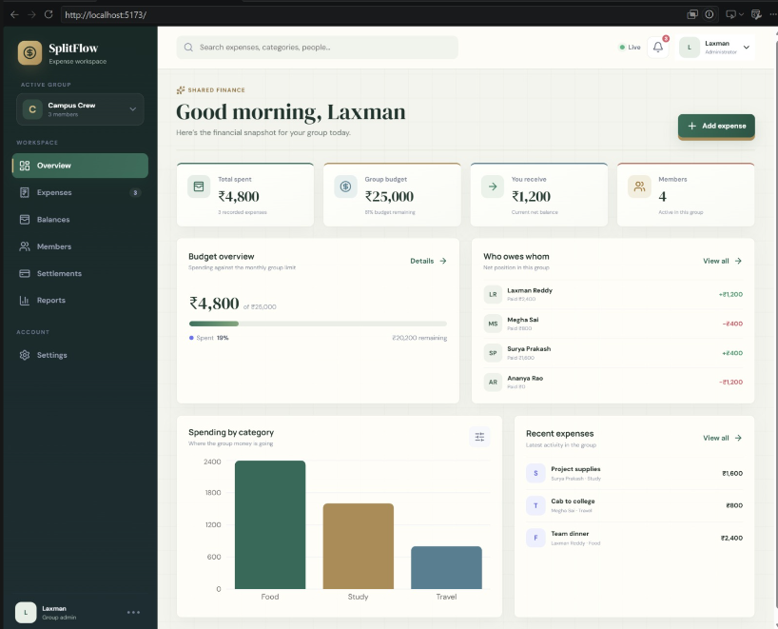

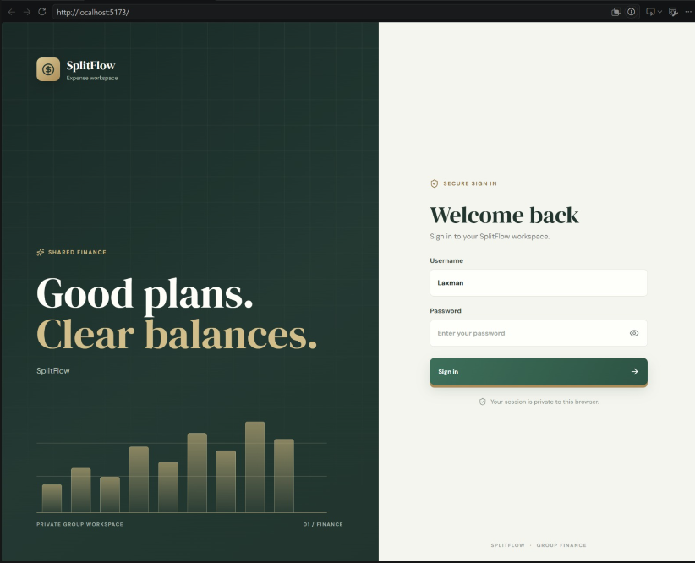

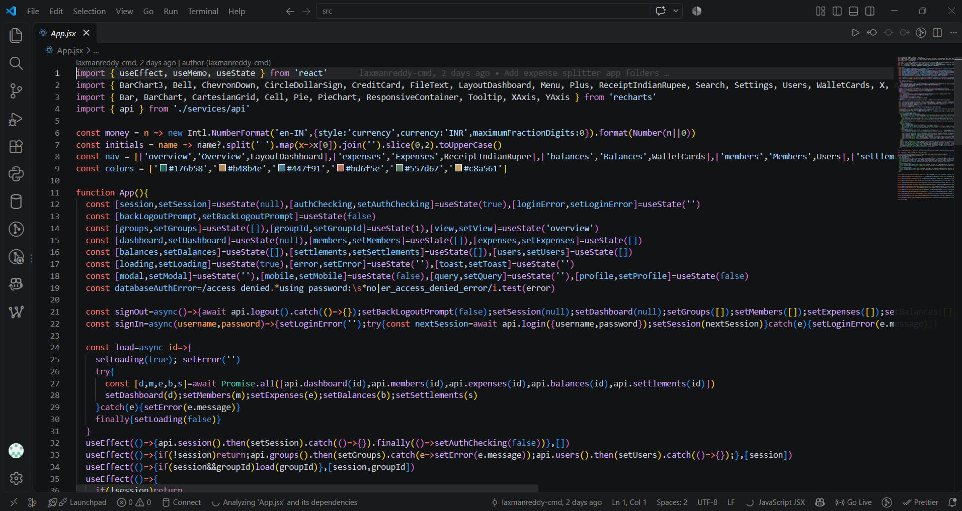

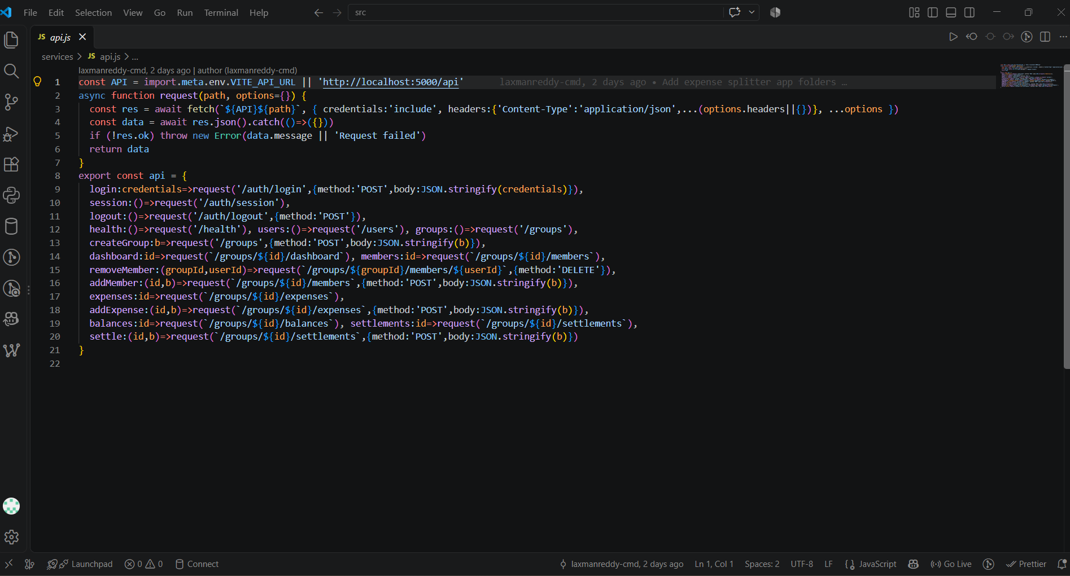

14.1 Installation and Verification Instructions
Prerequisites: Ensure Node.js (v18+) and MySQL Server 8.0 are installed.
1. Database Setup:
Execute database/schema.sql in MySQL Workbench.
2. Backend Setup:
cd backend
copy .env.example .env
npm install
npm run dev
3. Frontend Setup:
cd frontend
npm install
npm run dev
4. Access Application:
Navigate to http://localhost:5173 in any modern web browser.

14.2 Key Source Code References
• Relational Schema: database/schema.sql
• REST API Server: backend/src/server.js
• Database Connector: backend/src/db.js
• API Client Service: frontend/src/services/api.js
• UI Application Controller: frontend/src/App.jsx
• Postman Collection: postman/Expense-Splitter-Pro.postman_collection.json

